**Summary User Experience Design: stages, activities, techniques and tools.**

Jesse James Garrett's approach to the elements of User Experience (UX)

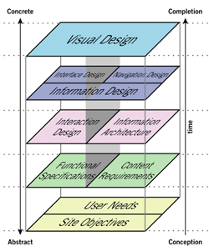

The stages defined for the creation of a software product. It is important to note that software creation is a spiral process.

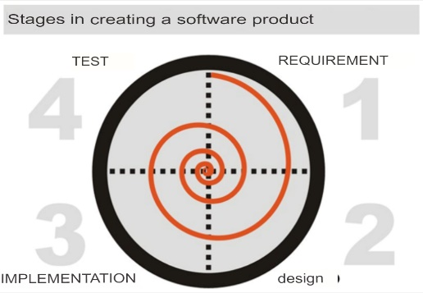

Two ways of approaching these stages of software development are defined: linear and iterative. The linear way consists of going through the four stages sequentially, while in the iterative approach the software cycle itself is repeated until the desired product is achieved.

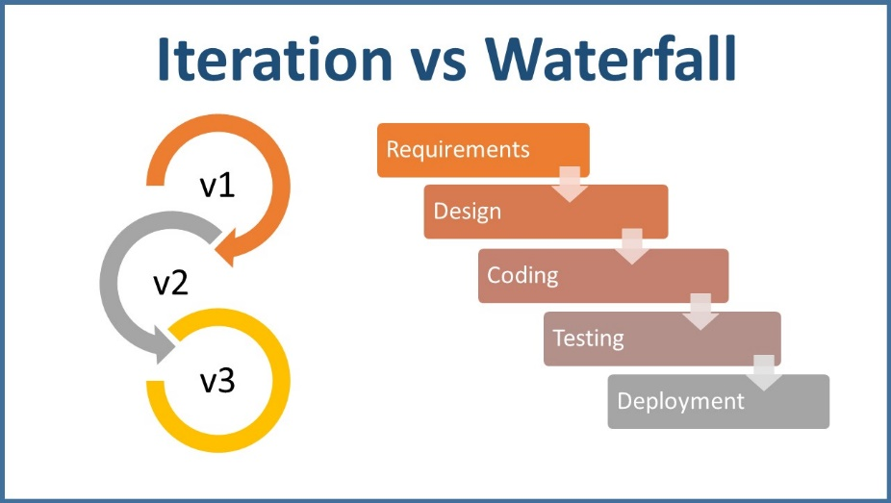

The role played by the User Experience Designer within software design can be seen as a communicative process, inspired by the Shannon-Weaver communication model. That is, the designer becomes a mediator between:

* The communication needs established by the person or institution requesting or ordering the product (customers).
* The informational and functional needs of the people who are going to use the product (users).

In this way, the function of the designer is precisely to achieve a balance in this communicative process between Issuers (clients) and Receivers (users).

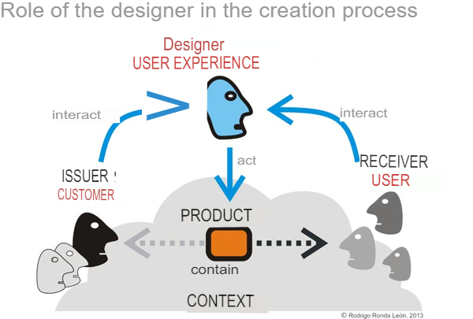

In software creation, the design stages are conditioned by the three elements described by Morville (2004), who point out that every project is related to users, context and specific content in each case.

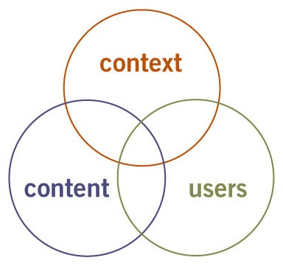

**Stages: They are those that respond to the elapsed time, when?**

The stages are divided into four moments through which the work of the software designer passes:

* Research: in which all possible information about the project, users and product to be designed is obtained.
* Organization: in which all the information is processed to turn it into a product.
* Design: in which the design of the product is reflected from what is organized.
* Test: in which the quality of the proposed design is checked.

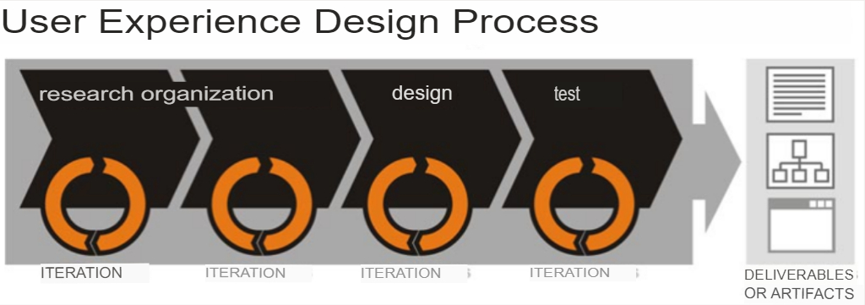

These stages can be viewed in the same way that software life cycle stages were viewed, that is, both linearly and iteratively. The result of these stages materializes in the form of deliverables or artifacts.

**Activities or tasks: They are those that respond to the process, what?**

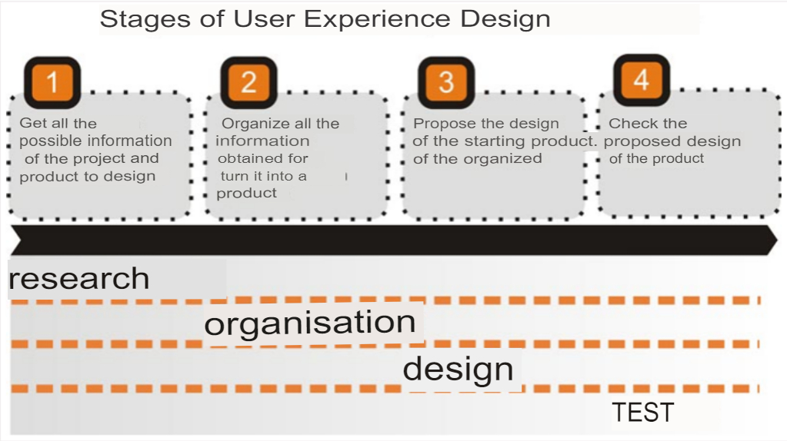

* STAGE 1 – INVESTIGATION

During this stage, the aim is to obtain as much information as possible and necessary for the project to be carried out, both about the client and the users.

* STAGE 2 - ORGANIZATION

This is the stage that is most related to artistic expression. It is when the designer uses both scientific-technical and cultural criteria to organize all the information obtained during the previous stage.

* STAGE 3 - DESIGN

It is the stage in which the results of the previous stage are reflected, now with all the technical requirements so that they are understood by users, clients and the rest of the work team.

* STAGE 4 - TEST

It is the stage in which the design proposals are checked. Testing is done with both clients and users.

**Techniques: They are the ones that respond to what is done to achieve the processes and task, how?**

The techniques are not necessarily related to activities or stages, so they can be used at any point in the project.

There are techniques that have greater use during some stage or activity, but they are not restricted to them. As a curious fact, techniques can be mixed with each other to achieve a specific objective.

**Tools: They are the ones that respond to what is used to apply the techniques. With what?**

The tools for the work of the user experience designer vary according to the economic and technological possibilities of the project. In the market there are both professional tools with a high monetary cost and free tools.